ADD “New Here” Tab at top
GENERAL:
- For each tab on the menu that has a sub-menu – can we have the first page (the page that it is directed to when the main title is clicked) be the first option in the sub-menu).
  - For Next Steps we’d need to add a Worship +2 sub option (the first option)
  - Then, for “who we are” and “programs” we can just delete the first page that is filled with Latin.

Home
- Replace pic of Grady speaking to diff pic of Grady Need pic
- ?? Where does “What’s Going On AT MFUMC” feed from? Originally, this fed from the super-cool events module on the site. Now, the ugly one is pulling from Seraphim.
  - Change to “Upcoming Events”
- Connect Events to Calendar This is going to be tricky. The only ways we can display content that’s been added to Seraphim can be seen here: http://madisonfumc.com/new/events/ One is a long, thin (not adjustable) list with no links to the events, and the other is a Google-calendar-looking thing.
- Scrolling pics under Sunday School – add Sunday school group pics and slow down
- Text for FLICKR FEED
  - Here’s just a glimpse of ministry in motion at Madison First UMC
  - ?? Can you have it just feed from the “Website” folder on Flickr? I’m unsure how to pull from just that folder. Will require investigation.
- Can we delete everything else between the Flickr feed and footer
- Where does the “Latest Updates” pull from? This pulls from the latest pages or posts that are added to the site. If you’re not planning on adding pages regularly to the site, then I’d suggest we remove or replace it.

Next Steps (Worship + 2??)
Main page
- Make first sentence under graphic more prominent
- Make the three paragraphs vertical – no horizontal spread
- 3 Buttons under paragraphs:
  - “Volunteer Opportunities” – linking to volunteer page
  - “Grow Opportunities” – linking to grow page
  - “Sign-Up Here” – linking to Seraphim Form Need Link#
Volunteer
- Add prominent button after intro paragraph that says “Sign-Up Here” – linking to Seraphim Form Need Link#
Grow
- Instead of “Click here to Sign-Up” can we have a prominent button after the first paragraph that says “Sign-Up Here” – linking to Seraphim Form. Need Link#
- Remove Latin title
- Can we change the format of this page?
- Three sections: Sunday School Groups, Small Groups, Fellowship Groups
- In each section list: group, pic, button “Sign-Up Here” – linking to Seraphim Form
  - This info is below
Missions
- Remove Latin Title
- Before the list of groups AND after list of groups Add prominent button after intro paragraph that says “Sign-Up Here” – linking to Seraphim Form Need Link#
Intercessory Prayer
- Remove box of info that says “Become a prayer . . .”
- Add prominent button after intro paragraph that says “Sign-Up Here” – linking to Seraphim Form Need Link#
- Can we change the format of the cycling quotes? Make it prettier and have it slow down.
- Where is the prayer request form going to? Currently it’s coming to me. Where do you want it to go?

Who We Are
- Move History to first tab. And, on the history page there is an odd indent in the text. Also, let’s pull some old pics for this page. Need Pics
- Remove core beliefs
- Add staff pics to staff page (pull what you can from old site for now please😉 No pics on staff page.
- Our location – is there a way that you and I could create a campus map of sorts? Is there a program that would help us do this? On this paged I’d like to see: Asking Chris to do this.
  - Address, Phone, ect.
  - Campus map
  - Parking instructions

Programs
- KIDZ LIFE
  - Change the layout so that we have two headings: Sunday Mornings and Sunday Evenings
  - Sunday Mornings
    - Sprouts Nursery
    - KIDZ Church
    - KIDZ Grow Sunday School
    - Grapple Tweens – CHANGE TITLE TO KIDZ Club Sunday School
    - Acolytes
  - Sunday Evenings
    - KICK
    - KIDZ CLUB
  - Can we add pics from FLICKR
  - Can we have KIDZ Calendar feed from Seraphim

- STUDENTS
  - Remove Latin title
  - Change layout so that we have three headings: Sunday Mornings, Sunday Evenings, Tuesday Mornings
  - Sunday Mornings
    - Sunday School
  - Sunday Evenings
    - CREDO
    - Madison Students Sunday Nights
  - Tuesday Mornings
    - TMD
  - Can we add pics from FLICKR
  - Can we have Student Calendar feed from Seraphim

- Preschool
  - We need to add pictures

Sermons
- Can we remove the “Home” “Praise Team” and “Test” links?

Give
- Remove latin title
- Add active, prominent “Give Now” button connected to our giving

NEW TAB – QUICK LINKS
- Prayer Request Form (link to prayer form from IPM page)
- Facility Rentals - Link to another page that has list of links to:
  - Wedding Guide for Non-Members (Link to PDF)
  - Wedding Guide for Members (Link to PDF)
  - Facility Usage Policy (Link to PDF)
  - Facility Usage Fee Schedules (Link to 3 PDFs)
  - Facility Usage Request Form (link to Seraphim)

Sunday School Groups
SEEKERS
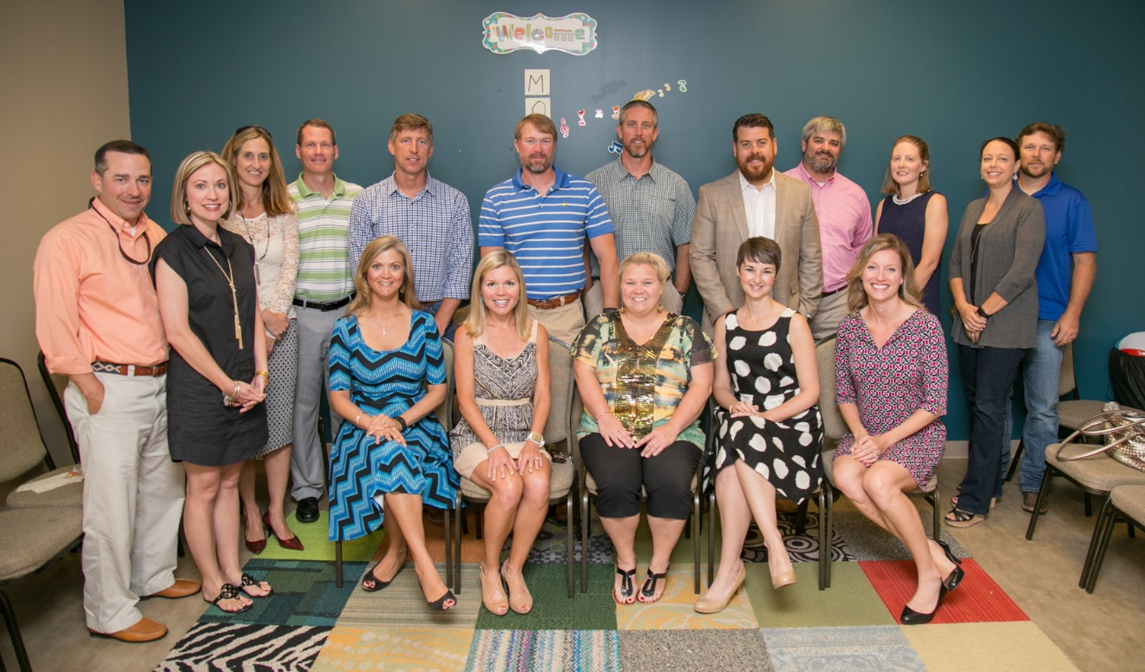The Seekers group is composed mostly of couples (though, singles are welcome!) in their 30s and 40s who are seeking a deeper relationship with God. Having a common ground, this group strives to create a better Christian environment for all, and it provides healthy means for coping with the daily grind.
Approximate Age Group: 30-45
Type: Mixed Adult (mostly couples)
Day: Sundays
Time: 10:00 AM—10:45 AM
Location: Wesley 101
Leader: Catherine Simmons

MILESTONES
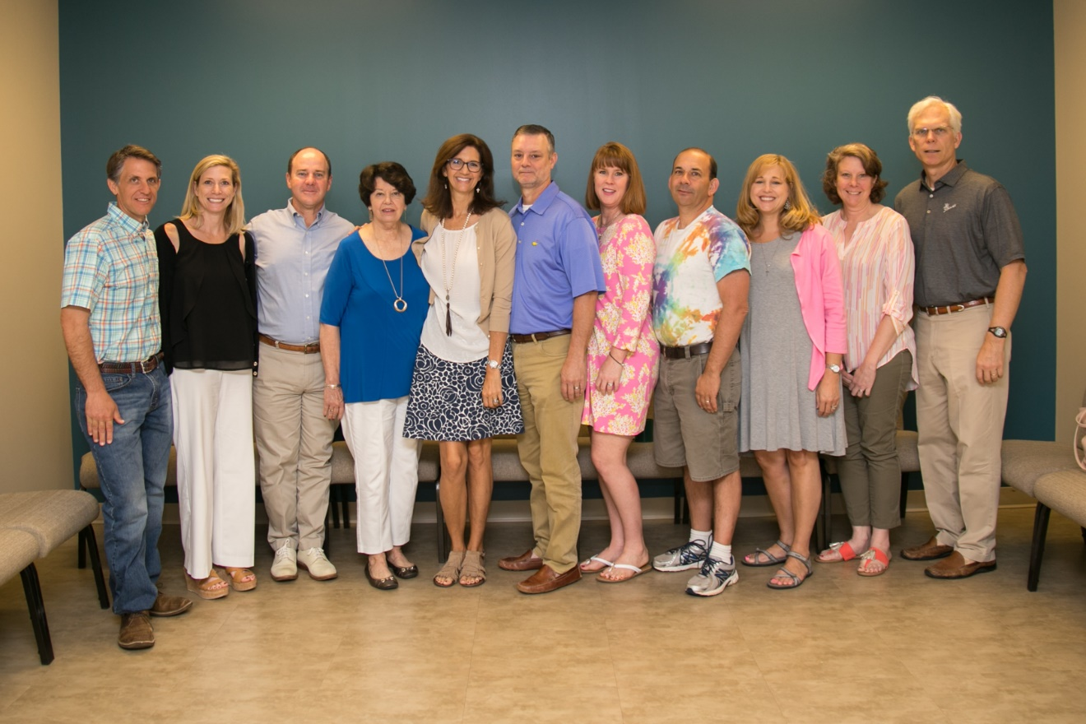Milestones are a self-taught group of couples (though, singles are welcome!) in their 40s and 50s with mostly high school and college-aged children. We enjoy Bible studies, but also look for studies which apply Biblical principles to everyday life. And we enjoy each other's company - inside and outside of church.
Approximate Age Group: 40-60
Type: Mixed Adults
Day: Sundays
Time: 10:00 AM—10:45 AM
Location: Wesley 112
Leader: Kathryn Cardwell

GOOD NEWS
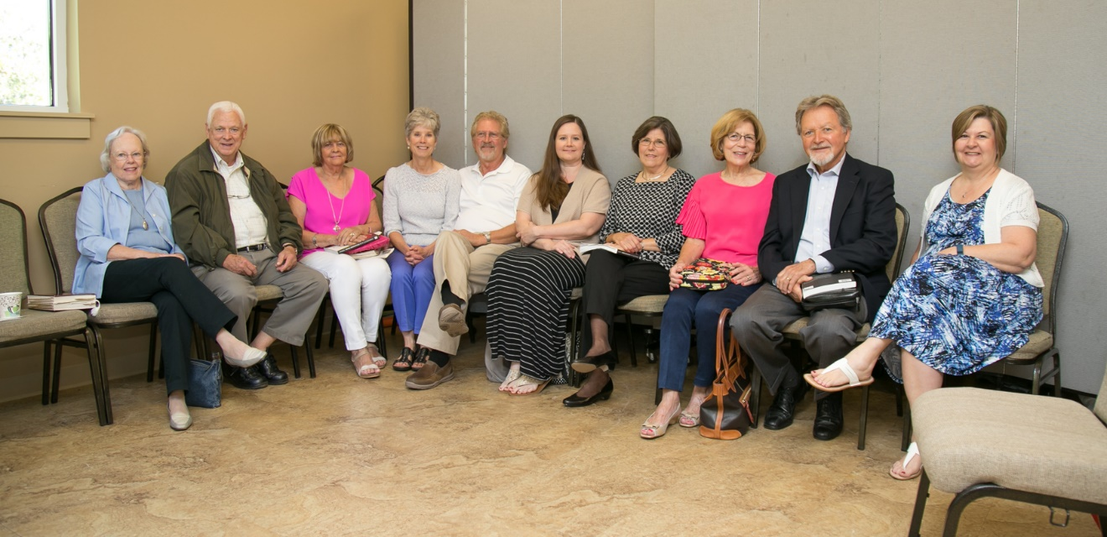
We are a mixed age group of couples and singles from 45 to 85. We primarily use the Life Bible Study curriculum. We feature lively class discussions and a good dose of fellowship as well.
Approximate Age Group: 45+
Type: Mixed Adults
Day: Sundays
Time: 10:00 AM—10:45 AM
Location: Asbury 205
Leader: Roberta Watson

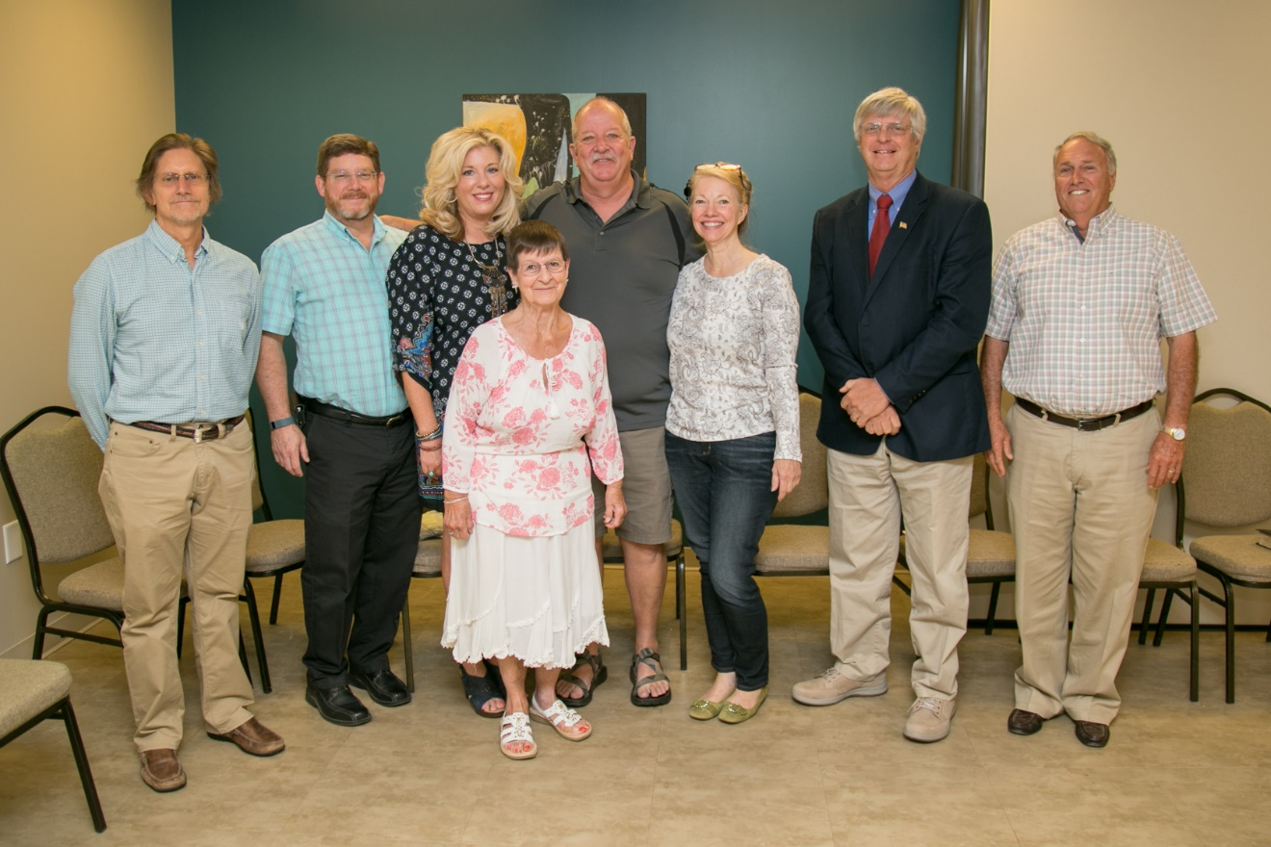10 ALIVE
The 10 Alive Sunday School Class is a group that is made up of adults of all ages and genders, married or single. Each week members study different portions of the Bible, share. Everyone is welcome!
Approximate Age Group: All Adults
Type: Mixed Adults
Day: Sundays
Time: 10:00 AM—10:45 AM
Location: Wesley 102-103
Leader: John Miles

EASTER
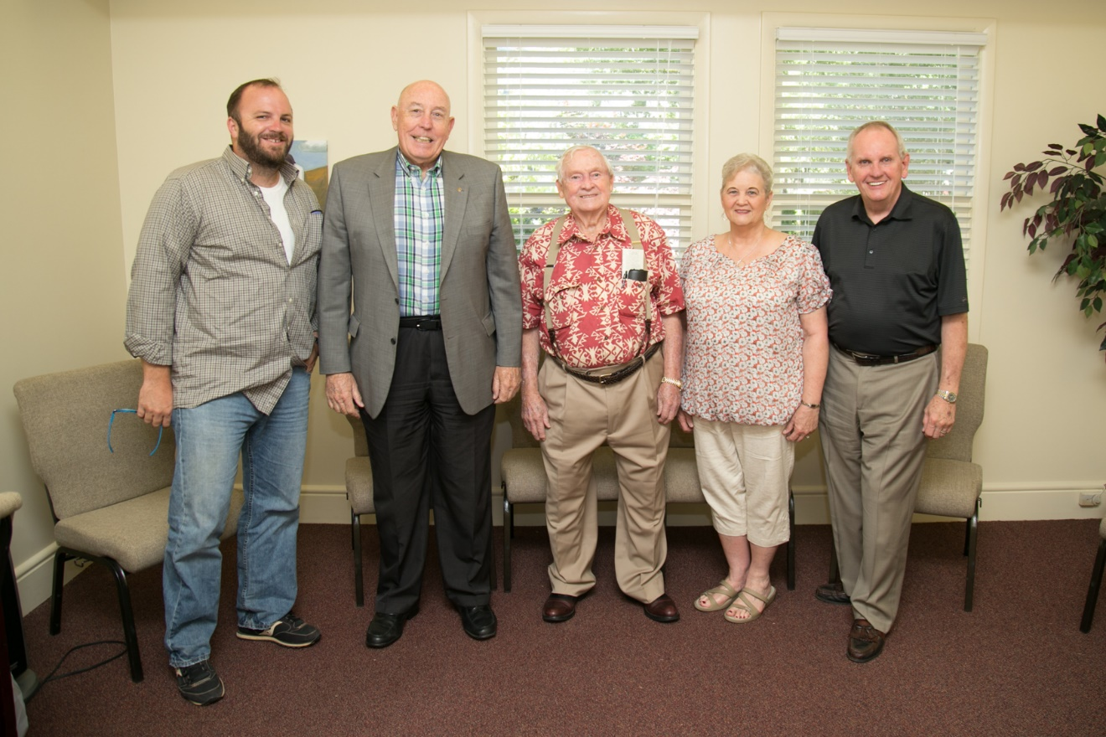
The Easter Sunday School class is made up of men and women, ages 50+. We follow the Cokesbury International Sunday School lesson with special lessons from occasional guest teachers.
Approximate Age Group: 50+
Type: Mixed Adult
Day: Sundays
Time: 10:00 AM—10:45 AM
Location: Epworth 203
Leader: Jimmy Stokes

OLIN EVERITT SUNDAY SCHOOL CLASS
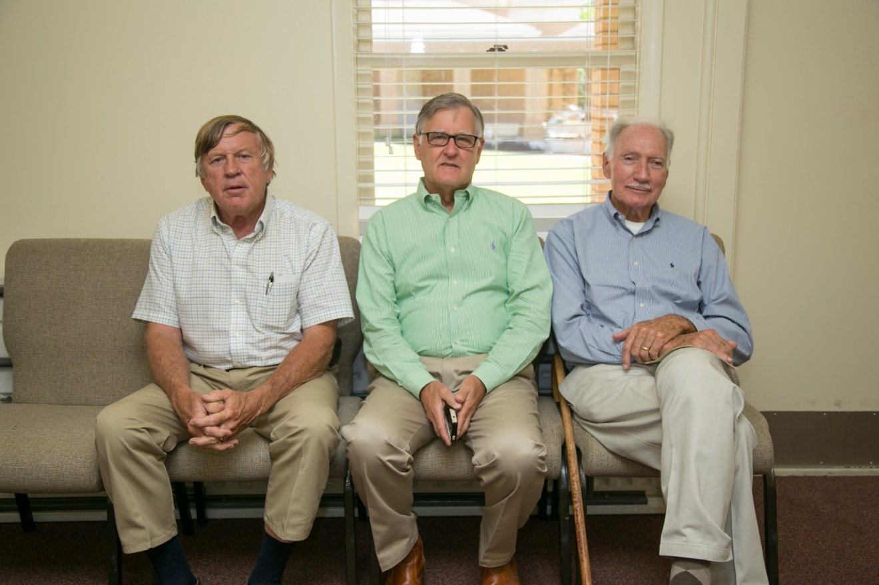
This is a self-taught class of congenial gentlemen 65+ of age. We try to conduct a comprehensive study of the Bible. We use the uniform series of International Bible Lessons. Everyone is welcome to visit or join.
Approximate Age Group: 65+
Type: Men’s Group
Day: Sundays
Time: 10:00 AM—10:45 AM
Location: Epworth 201
Leader: Warren Few

HERITAGE SUNDAY SCHOOL CLASS
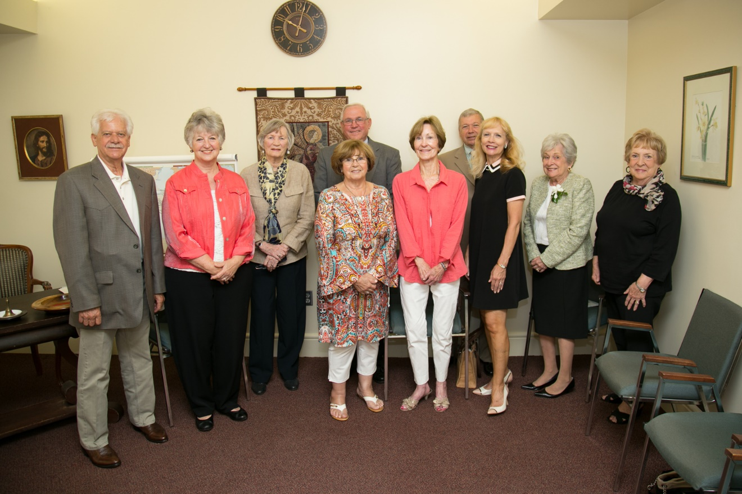
This class is comprised of ages 55+, women and men, married or single. All are welcome. Teachings come from the International Sunday School Uniform Study which gives an overview of the Bible in a six-year cycle. A rotation of four teachers lead the lessons and the group takes a collection each Sunday to support charitable causes.
Approximate Age Group: 55+
Type: Mixed Adult
Day: Sundays
Time: 10:00 AM—10:45 AM
Location: Epworth 202
Leaders: Donna Martin & Sue Foy

NEW COVENANT
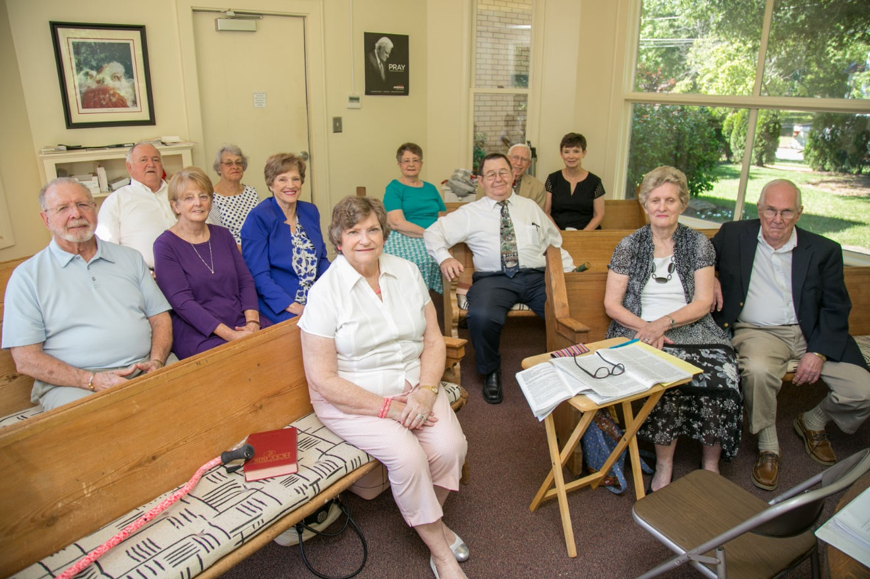The New Covenant Sunday School Class is composed of couples and singles, ages 55+. The International Lessons are taught by rotating teachers. The class donates to many needs in the community and other worthy causes. Outings are enjoyed during the year. Everyone is welcomed.
Approximate Age Group: 55+
Type: Mixed Adult
Day: Sundays
Time: 10:00 AM—10:45 AM
Location: Epworth 204
Leader: Anelle Argo

SONSHINER’S SUNDAY SCHOOL CLASS
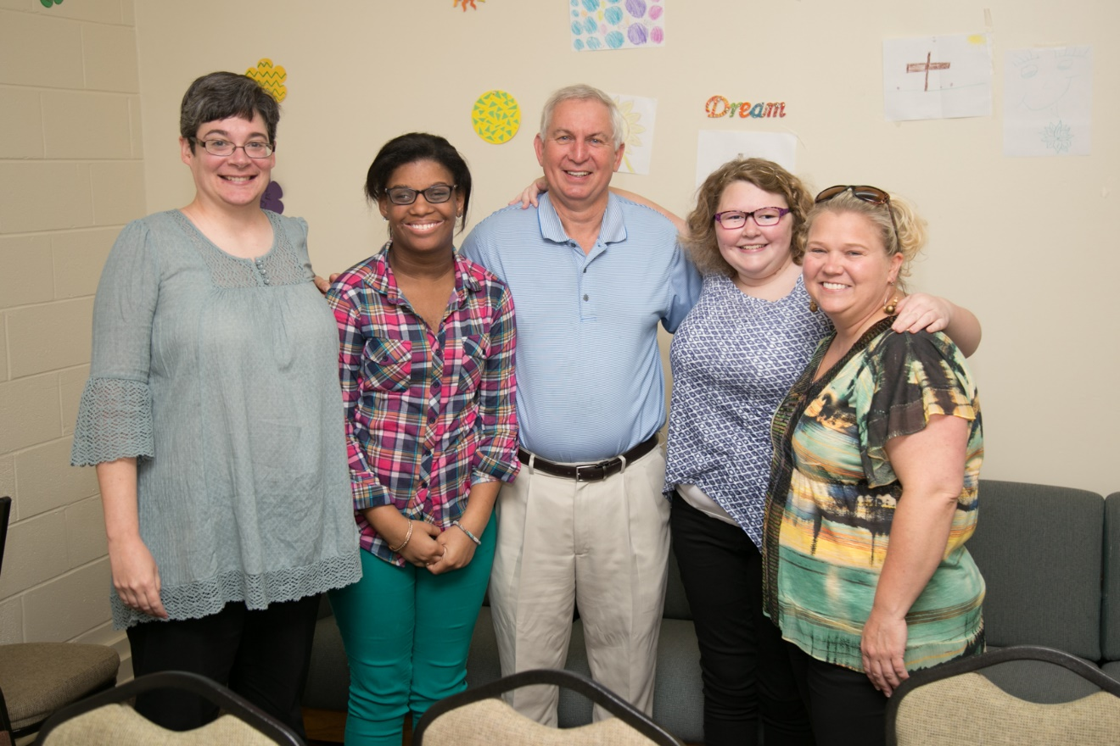The Sonshiner's Sunday School class was created for intellectually challenged teenagers and adults, as well as for others with special needs. On the 4th Sunday of each month, participants go out to eat together at a local restaurant after Sunday School. The group also goes on seasonal outings together.
Approximate Age Group: 13-Adult
Type: Special Needs
Day: Sundays
Time: 10:00 AM—10:45 AM
Location: Epworth Youth Center
Leader: Fran Holmes

Young Adult Sunday School Class
A Sunday School Class for Young Adults—Ages 24-early 30s.
Approximate Age Group: 24-early 30s
Type: Young Adult
Day: Sundays
Time: 10:00 AM—10:45 AM
Location: Wesley 201
Leader: Deborah Mosley

KIDZ GROW SUNDAY SCHOOL CLASSES
Sundays at 10AM are fun, dig-deep learning times for our Pre-K—5th Grade kids. Kids are broken into age based groupings and engage in Bible teaching and discussion with the goal of instilling three powerful truths: I need to make the wise choice, I can trust God no matter what, and I should treat others the way I want to be treated.
Approximate Age Group: Pre-K-5th Grade
Type: Kids
Day: Sundays
Time: 10:00 AM—10:45 AM
Location: Wesley Basement
Leader: Debbie Britt

STUDENT SUNDAY SCHOOL CLASS
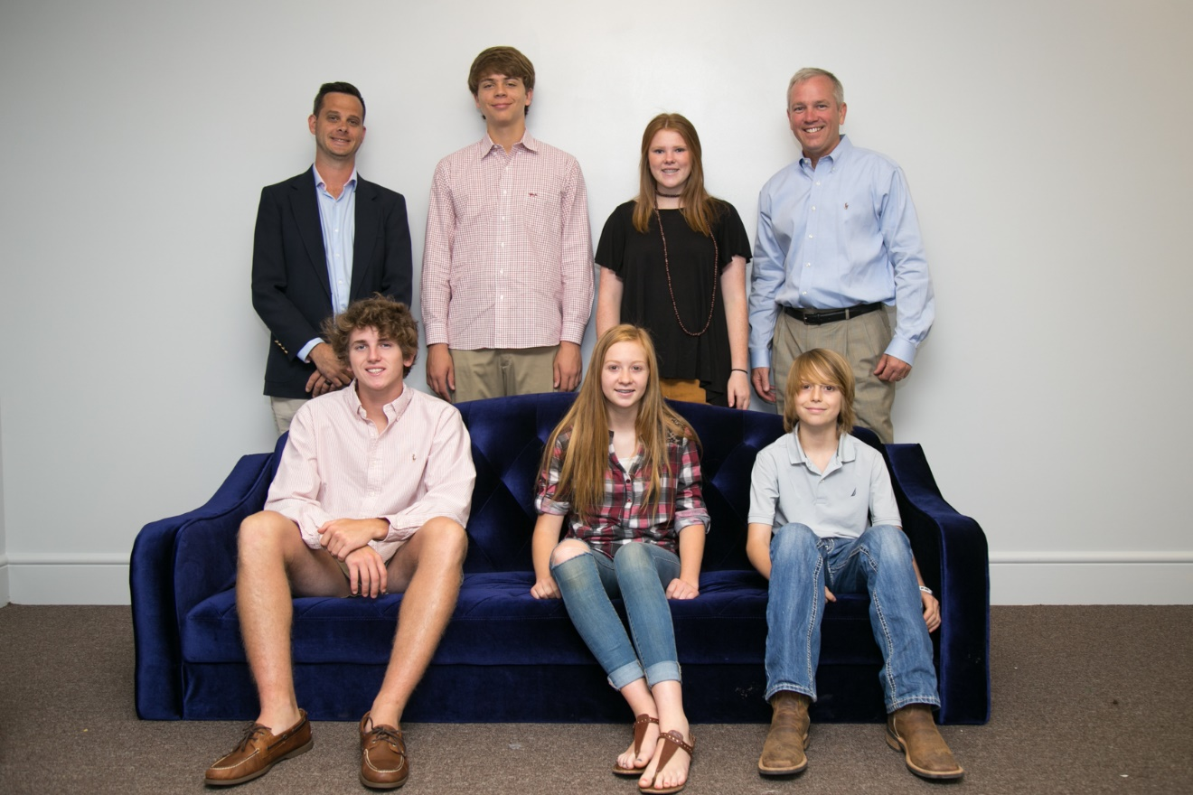Each Sunday the Madison Student Ministry hosts a Sunday School Class for students from 6th—12th grade. Come for donuts, juice, a fierce game of ping-pong and a relevant, life-based teaching of Scripture.
Approximate Age Group: 6th-12th Grades
Type: Students
Day: Sundays
Time: 10:00 AM—10:45 AM
Location: Epworth Youth Center
Leader: Garrett Bearden

Small Groups
WOMEN’S BIBLE STUDY (Sunday Evening)
This is a short-term Bible Study (approximately 8-weeks) that is offered twice a year— after Labor Day and around Lent. The groups offers a video based Bible Study, faith building discussion, and time for fellowship and fun.
Approximate Age Group: All Ages
Type: Women’s Group
Day: Sundays (SEASONAL)
Time: 5:00 PM—7:00 PM
Location: Wesley 103
Leader: Deborah Mosley

WOMEN’S BIBLE STUDY (Thursday Morning)
This group meets weekly to engage in Bible Study, faith building discussion, and fellowship. Bible Study materials change throughout the year and cover many topics and Biblical themes.
Approximate Age Group: All Ages
Type: Women’s Group
Day: Thursdays
Time: 10:00 AM—12:00 PM
Location: Asbury Choir Room
Leader: Bunnie Schimitt and Claire Zant

YOUNG ADULT SMALL GROUP
This is a Bible Study for those ages 24—early 30s. The Young Adult Small Group is a place to come for Godly fellowship, discussion, laughter, and teachings that will help you grow deeper in faith.
Approximate Age Group: 24-early 30s
Type: Young Adult
Day: Wednesdays
Time: 7 PM
Location: Home of Brooks & Cecily Pennington
Leaders: Brooks & Cecily Pennington

WOMEN’S COMMUNITY BIBLE STUDY
This is an interfaith community based group that is open to women of all ages. Each weekly meeting offers a video based Bible Study, faith building discussion, and time for fellowship and fun.
Approximate Age Group: All Ages
Type: Women’s Group
Day: Wednesdays
Time: 10:00 AM—12:00 PM
Location: Epworth Youth Center
Leader: Jean Wood & Betsy Briley
**Note: This group is a community based group and it is not overseen by Madison First UMC.

MEN’S COMMUNITY BIBLE STUDY
This is an interfaith community based group that is open to men of all ages. The weekly meetings center on the study and discussion God’s word and how to apply faith to the rigors of life.
Approximate Age Group: All Ages
Type: Men’s Group
Day: Tuesdays
Time: 7:00 AM—8:00 AM
Location: Farm Bureau
Leader: John Miles
**Note: This group is a community based group and it is not overseen by Madison First UMC.

Fellowship Groups
PRIME TIMERS
Prime Timers is a Senior Ministry that meets on the 4th Thursday of each month at noon for a luncheon and special program. The group also plans day trips and overnight trips to exciting places.
Approximate Age Group: 55+
Type: Mixed Adult
Day: 4th Thursdays
Time: 12:00 PM—1:30 PM
Location: Wesley Worship Center (typically)
Leader: Tom Womack & Anelle Argo

UNITED METHODIST WOMEN
The United Methodist Women is a mission minded organization that meets the 1st Tuesday of the month in members' homes. Our emphasis is on local missions as well as national and international missions. Different study books are used for programs and are taught by members. The group enjoys fellowship with all ages.
Approximate Age Group: All Ages
Type: Women
Day: 1st Tuesdays
Time: 7:00 PM—9:00 PM
Location: Varies
Leader: Teri Dobie

UNITED METHODIST MEN
Open to all men of the church—we meet the first Sunday of each month for breakfast. Our passion is to help kids in our community through fundraisers and food. We support many programs in the community such as FCA, Young Life, Boys and Girls Club, Camp Scholarships, and The Caring Place.
Approximate Age Group: All Ages
Type: Men
Day: 1st Sundays
Time: 7:00 AM—8:00 AM
Location: Wesley Worship Center
Leader: Jim Abeel

